Unit 5 Grade 10 Applied

Introduction to Quadratic Relations

Lesson Outline

BIG PICTURE

Students will:
- identify characteristics of quadratic relations;
- solve problems by interpreting graphs of quadratic relations.
Day | Lesson Title | Math Learning Goals | Expectations
1 | Going Around the Curve | - Collect data that can be modelled by a quadratic relation, using connecting cubes, and calculate first and second differences.  - Draw the curve of best fit on chart paper.  - Realize that the shape of the graphs are curves rather than lines.  - Communicate students’ findings from the experiments to the entire class.  - Define the shape of the curves of best fit as a parabola. | QR2.01  CGE 2c, 4f, 5a, 7j
2 | Making a Difference | - Determine that if the table of values yields a constant second difference the curve is parabolic and vice versa.  - Realize that there are other non-linear relationships that are not parabolic.  - Develop a word wall of new vocabulary related to the quadratic. | QR2.02  CGE 5a, 5b
3 | Features of Parabolic Graphs | - Identify the key features of parabolic graphs created on Days 1 and 2 (the equation of axis of symmetry, the coordinates of the vertex, the y-intercept, x-intercepts (zeros), and the max/min value).  - Develop and use appropriate vocabulary related to parabolic curves. | QR2.03  CGE 4f
4 | Canada’s Baby Boom | - Collect data that can be represented as a quadratic relation from secondary sources.  - Graph the data and draw a curve of the best fit (parabola).  - Interpret data related to the context such as the maximum or minimum height.  - Determine that quadratic relations are of the form y = ax² + bx + c using technology. | QR3.01  CGE 4a, 7f
5 | Data Collection Using Balls | - Use technology to collect data that will produce a quadratic relation.  - Interpret data related to the context.  - Make predictions based on the context of the relation. | QR3.02  CGE 3c, 4f
6 | Summative Assessment | Note: A summative performance task is available from the members only section of the OAME web site www.oame.on.ca
7 | Jazz Day

Unit 5: Day 1: Going Around the Curve |  |  |  |  | Grade 10 Applied
  75 min |  | Math Learning Goals  - Collect data that can be modelled by a quadratic relation, using connecting cubes, and calculate first and second differences.  - Draw the curve of best fit on chart paper.  - Realize that the shape of the graphs are curves rather than lines.  - Communicate students’ findings from the experiments to the entire class.  - Define the shape of the curves of best fit as a parabola. |  |  | Materials  - linking cubes  - chart paper  - grid chart paper  - BLM 5.1.1, 5.1.2, 5.1.3, 5.1.4, 5.1.5
Assessment
Opportunities
 | Minds On… | Groups of 3 → Placemat  Students complete a placemat with the phrase “linear relationship” in the centre. They reflect on everything they recall about the characteristics of linear relations in their own section and share their results within their groups. They write the characteristics they agree upon in the centre. Repeat the process using the phrase “non-linear relationship.”  Summarize characteristics on chart paper and post.  Recall that first difference implies a linear relationship.  Show students how to find second differences, using an example.  Curriculum Expectations/Demonstration/Observation/Checklist: Observe what characteristics students recall about linear and non-linear relations. |  | Word Wall  - parabola  - quadratic equation/relation  - vertex  - axis of symmetry  - x-intercepts  - y-intercept  - zeros  - maximum/minimum value  - symmetry  These experiments provide “clean data” from which a constant second difference can be determined.  Students should see the full parabolic shape rather than just half.
 | Action! | Groups of 3 → Experiments & Presentations  Each group completes an assigned experiment (BLMs 5.1.1–5.1.5). They record their data in a table on chart paper, and plot the data on grid chart paper.  Learning Skills/Teamwork/Observation/Checklist: Observe how well students work as a productive team to complete the task.  Groups make any required changes, draw a large graph of their results, and present their findings to the class. Presentations should include the context provided in their problem; the models they constructed; the data they collected; an explanation of the pattern that they observed; the graphs they constructed; and the curve of best fit.
 | Consolidate Debrief | Whole Class → Discussion  Focus discussion on the shapes of the entire graph, including negative x values. Explain that this particular curve is called a parabola. Students take particular note of the constant second difference in the table of values, connecting to their understanding that linear relations have common first differences.  Explain that the common second difference identifies the resulting curve as a parabola. Students predict what their graph would look like if it was extended to negative values of the independent variable.
Concept Practice  Reflection |  | Home Activity or Further Classroom Consolidation  Complete practice questions as needed.  - Complete a journal entry using the following writing prompt:  Parabolic curves exist in the world in the following ways/places/actions…  OR  - Find pictures you think are parabolic and bring them to class. |  | Provide students with appropriate practice questions.

5.1.1: Going Around the Curve

Experiment A
A particular mould grows in the following way: If there is one “blob” of mould today, then there will be 4 tomorrow, 9 the next day, 16 the next day, and so on.
Model this relationship using linking cubes.

Purpose

Find the relationship between the side length and the number of cubes.

Hypothesis

What type of relationship do you think exists between the side length and the number of cubes?

Procedure

1. Build the following sequence of models, using the cubes.
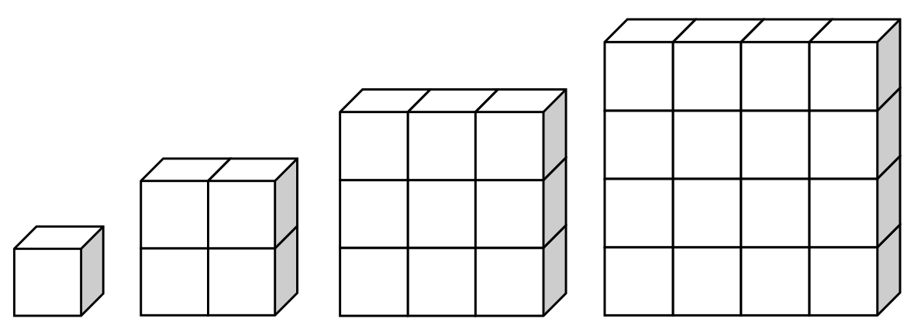

2. Build the next model in the sequence.

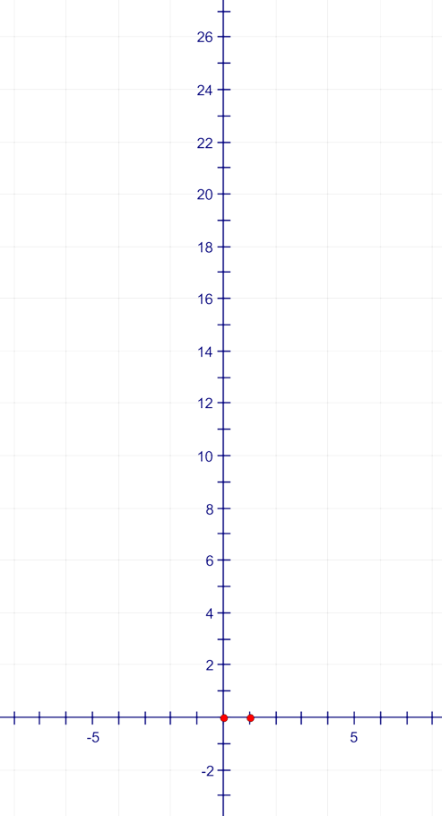
Mathematical Models
Complete the table, including first and second differences.
Make a scatter plot and a line of best fit.
Side Length | Number of Cubes
Side Length | Number of Cubes | First Differences
0 | 0 | First Differences | Second Difference

5.1.2: Going Around the Curve

Experiment B
Jenny wants to build a square pool for her pet iguana. She plans to buy tiles to place around the edge to make a full play area for her pet.
Model the relationship, comparing total play area (pool combined within the edging) to the side length of the pool, using linking cubes.

Purpose
Find the relationship between the side length of the pool (shaded inside square) and the total play area.

Hypothesis

What type of relationship do you think exists between the side length and the play area?

Procedure

1. Build the following sequence of models using the cubes.
Note: The pool is the shaded square, the tiles are white.
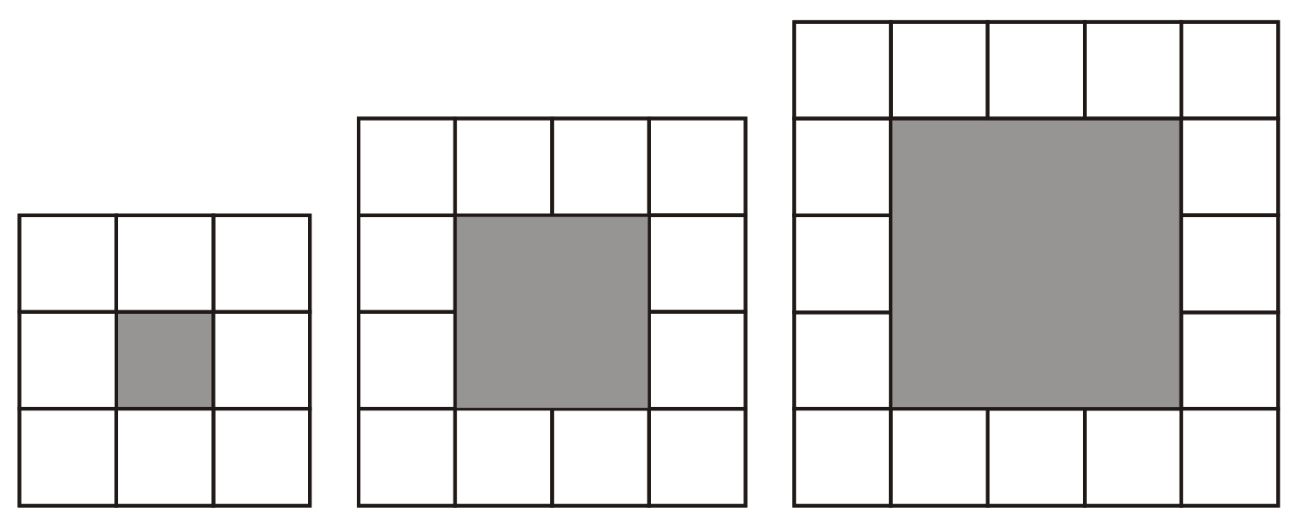

2. Build the next model in the sequence.
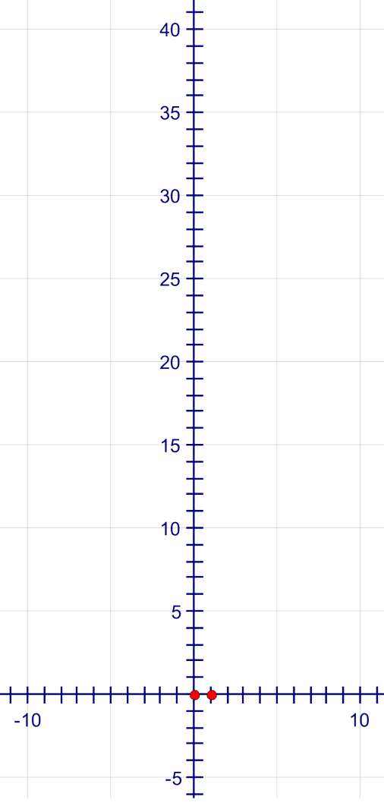

Mathematical Models
Complete the table, including first and second differences.
Make a scatter plot and a line of best fit.
Side Length | Total Play Area
Side Length | Total Play Area | First Differences
1 |  | First Differences | Second Difference

5.1.3: Going Around the Curve

Experiment C
A particular mould grows in the following way: If there is one “blob” of mould today, then there will be 3 tomorrow, and 6 the next day.
Model this relationship using linking cubes.

Purpose
Find the relationship between the number of cubes in the bottom row and the total number of cubes.

Hypothesis
What type of relationship do you think exists between the number of cubes in the bottom row and the total number of cubes?

Procedure

1. Build the following sequence of models using the cubes.
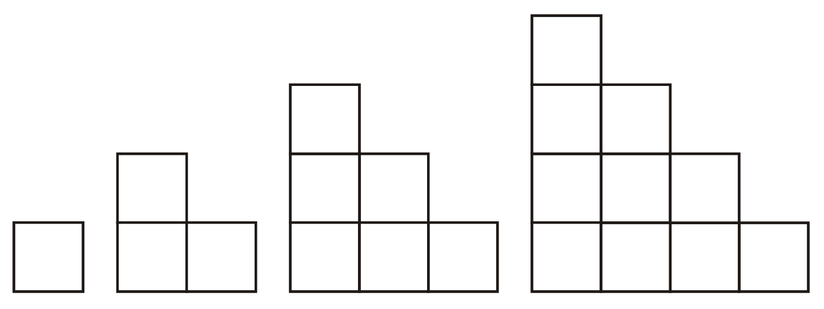

2. Build the next model in the sequence.

Mathematical Models
Complete the table, including first and second differences.
Make a scatter plot and a line of best fit.
Number of Cubes in the Bottom Row | Total Number of Cubes
Number of Cubes in the Bottom Row | Total Number of Cubes | First Differences
 |  | First Differences | Second Difference

5.1.4: Going Around the Curve

Experiment D
Luisa is designing an apartment building in a pyramid design. Each apartment is a square.
She wants to know how many apartments can be built in this design as the number of apartments on the ground floor increases.
Model this relationship, using linking cubes.

Purpose
Find the relationship between the number of cubes in the bottom row and the total number of cubes.

Hypothesis
What type of relationship do you think exists between the number of cubes in the bottom row and the total number of cubes?

Procedure

1. Build the following sequence of models using the cubes.
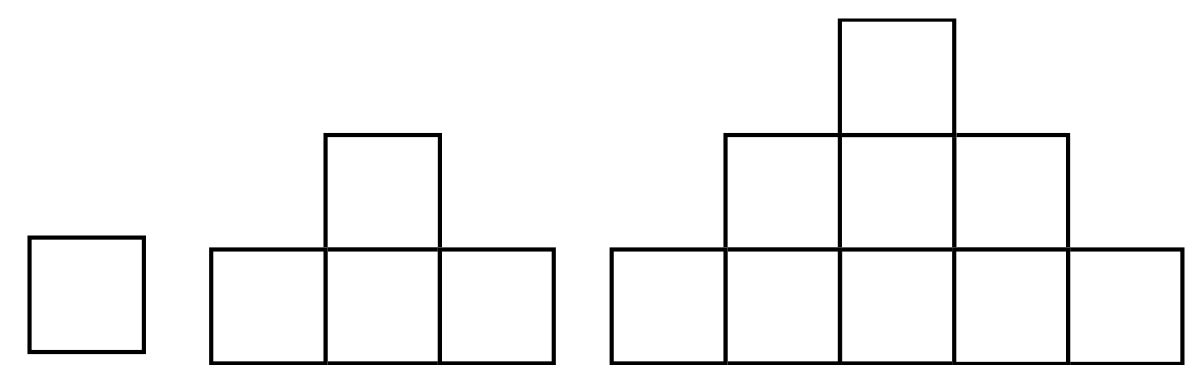

2. Build the next model in the sequence.

Mathematical Models
Complete the table, including first and second differences.
Make a scatter plot and a line of best fit.
Number of Cubes in the Bottom Row | Total Number of Cubes
Number of Cubes in the Bottom Row | Total Number of Cubes | First Differences
0 | 0 | First Differences | Second Difference

5.1.5: Going Around the Curve

Experiment E
Liz has a beautiful pond in her yard and wants to build a tower beside it using rocks. She is unsure how big she will make it and how many rocks she will need. She is particularly concerned to have the nicest rocks showing.
Model the relationship comparing the length of the base to the number of visible rocks using linking cubes.

Purpose
Find the relationship between the number of cubes on the side of the base and the total number of unhidden cubes.

Hypothesis
What type of relationship do you think exists between the length of the side of the base and the number of visible cubes?

Procedure

1. Build the following sequence of models using the cubes.
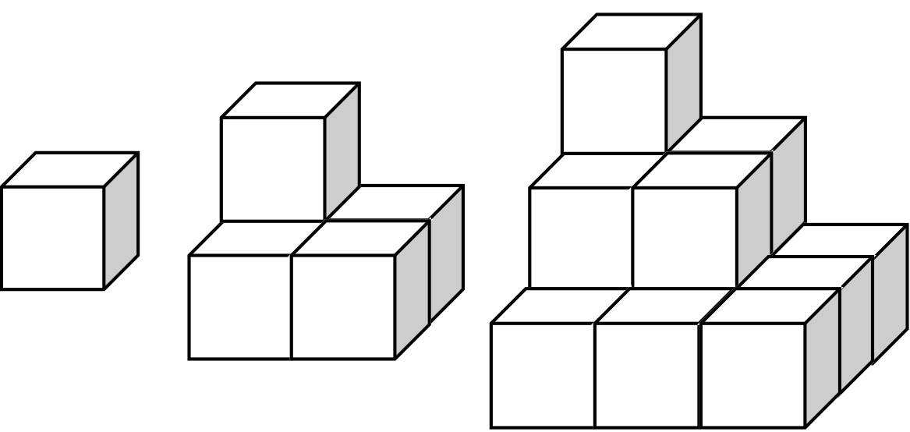

2. Build the next model in the sequence.

Mathematical Models
Complete the table, including first and second differences.
Make a scatter plot and a line of best fit.
Length of Side of Base | Total Number of Unhidden Cubes
Length of Side of Base | Total Number of Unhidden Cubes | First Differences
 |  | First Differences | Second Difference

Unit 5: Day 2: Making a Difference |  |  |  |  |  | Grade 10 Applied
  75 min |  | Math Learning Goals  - Determine that if the table of values yields a constant second difference the curve is parabolic and vice versa.  - Realize that there are other non-linear relationships that are not parabolic.  - Develop a word wall of new vocabulary related to the quadratic. |  |  |  | Materials  - connecting cubes  - graph paper
Assessment
Opportunities
 | Minds On… | Whole Class → Investigation  Demonstrate a linear relationship, using the following construction.  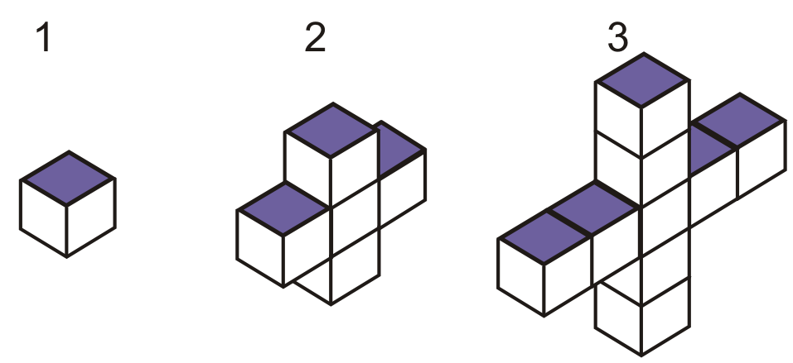  Students individually complete a table of values with the headings Model Number, Number of Cubes, and First Difference and create a graph of the information. They connect the first difference with the slope of the line and reflect on the value of difference to determine if the relationship is linear or non-linear, and provide reasons for their conclusions. |  |  |  | Before continuing, students should have the understanding that the first differences are not the same and therefore the data is non-linear.  Students can confirm their predictions by selecting other sets of data from the experiments.
 | Action! | Pairs → Summarizing  Students refer to data from any two experiments completed on Day 1. Engage student thinking by providing prompts: Prove that the data is non-linear.  Further prompting: We know all the graphs are parabolas; we call these quadratic relations.  Ask:  - How could we know that they are parabolas just from the table of values?  - What pattern do you see in the work you’ve done on the tables?  Students complete the statement: The graph of a table of values will be a parabola if....  Curriculum Expectation/Demonstration/Checklist: Assess students’ understanding that a constant second difference in a table of values determines that the relation is quadratic.  Groups of 4 → Investigation  Students build cubes of sides 1, 2, and 3, and record on a table of values the side length and volume. They calculate the volume for side lengths 4, 5, and 6, and put the data on a graph.  Ask:  - Is this linear or non-linear?  - Is the curve a parabola?  - How can you verify this?
 | Consolidate Debrief | Whole Class → Discussion  Discuss and summarize facts:  - The table of values associated with parabolas always has a common second difference.  - There are other curves that are not parabolas. These curves do not have common second differences.
Concept Practice |  | Home Activity or Further Classroom Consolidation  Complete one task about parabolas:  - Determine if the situations are linear, quadratic, or neither, and provide reasons for your answers.  OR  - Place the parabolic picture that you brought to class on a grid and determine some of its points. Verify that it is or is not a parabola. |  |  |  | Provide a variety of situations and/or data that are linear, quadratic, or neither.
Unit 5: Day 3: Features of Parabolic Graphs |  |  |  |  |  |  | Grade 10 Applied
  75 min |  | Math Learning Goals  - Identify the key features of parabolic graphs created on Days 1 and 2 (the equation of axis of symmetry, the coordinates of the vertex, the y-intercept, x-intercepts (zeros), and the max/min value).  - Develop and use appropriate vocabulary related to parabolic curves. |  |  |  |  | Materials  - BLM 5.3.1, 5.3.2, 5.3.3  - scissors  - glue sticks
Assessment
Opportunities
 | Minds On… | Pairs à Timed Retell  Provide partners A and B with a different graph of a quadratic relation  (BLM 5.31). They should not see each other’s graph.  Student A describes the key features of the graph to student B. Student B sketches the graph from student A’s oral prompts. Students compare how close the sketch was to the given graph. The partners switch roles.  Whole Class à Discussion  Discuss the terms they used to describe their graphs to their partners. Emphasize the key features that were focused on in the descriptions.  Ask: Did you have difficulties identifying or describing any of the key features? If so, what was the difficulty? |  |  | Word Wall  - axis of symmetry  - vertex  - the y-intercept  - zeros  - max/min value  The “Zero” is the value of x when y = 0
 | Action! | Whole Group à Guided Instruction  Guide students in defining the terms that describe the features of a parabola and label the graphs, using appropriate terminology (BLM 5.3.2).  Connect the terminology to parabolic graphs created from real data.
 | Consolidate Debrief | Groups of 3 à Discussion  Students rejoin groups of 3 and revisit the graphs they created on Days 1 and 2.  They cut out the key terminology (BLM 5.3.3) and glue them in the appropriate location on their graphs providing a rationale for their choice.  Curriculum Expectation/Demonstration/Mental Note: Observe students’ interpretation of the key features of a parabola as they identify these features of their graph.
Application  Concept Practice |  | Home Activity or Further Classroom Consolidation  Complete the practice questions. |  |  | Provide students with questions that include parabolas that represent real data.

5.3.1: Key Features of Parabolic Graphs

Student A has 30 seconds to describe the following graph to student B.
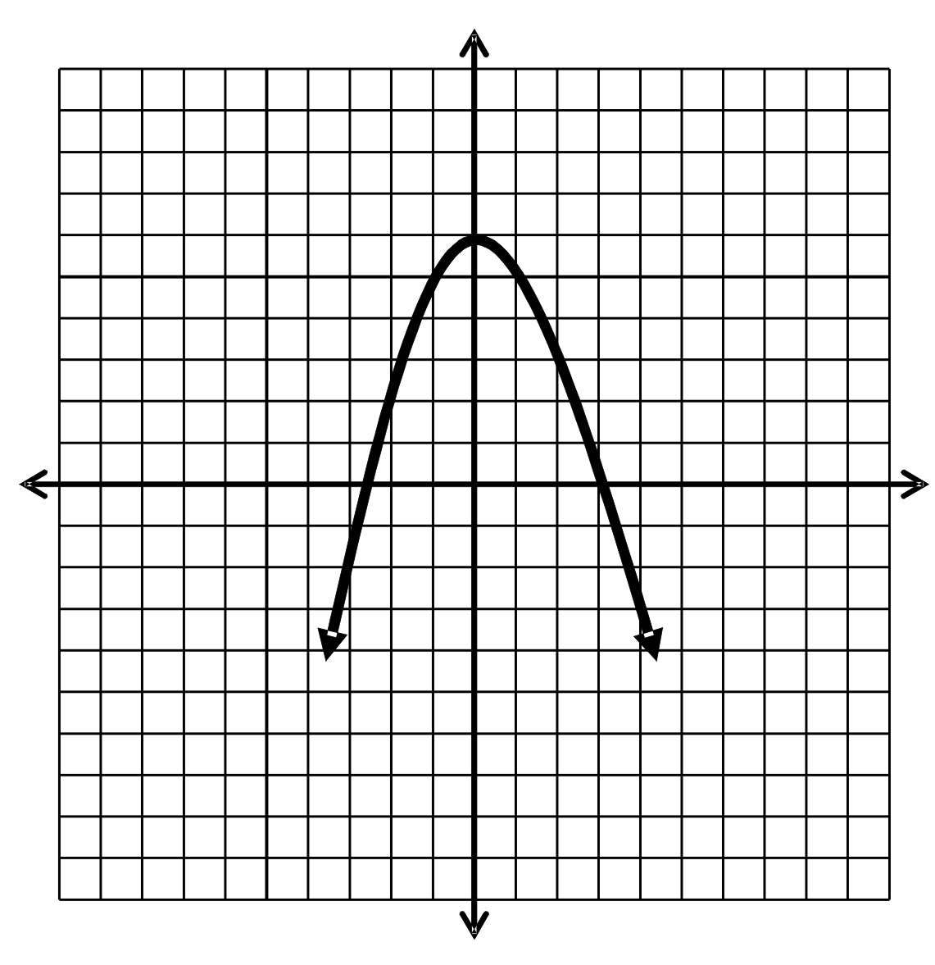

Using the grid below, student B sketches the graph described by Student A.

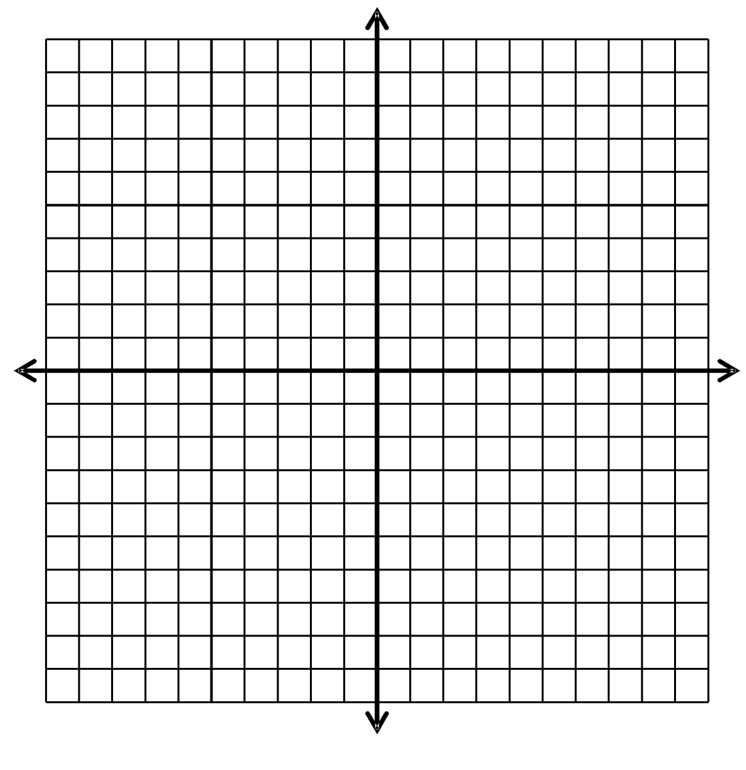

5.3.1: Key Features of Parabolic Graphs (continued)

Student B has 30 seconds to describe the following graph to student A.
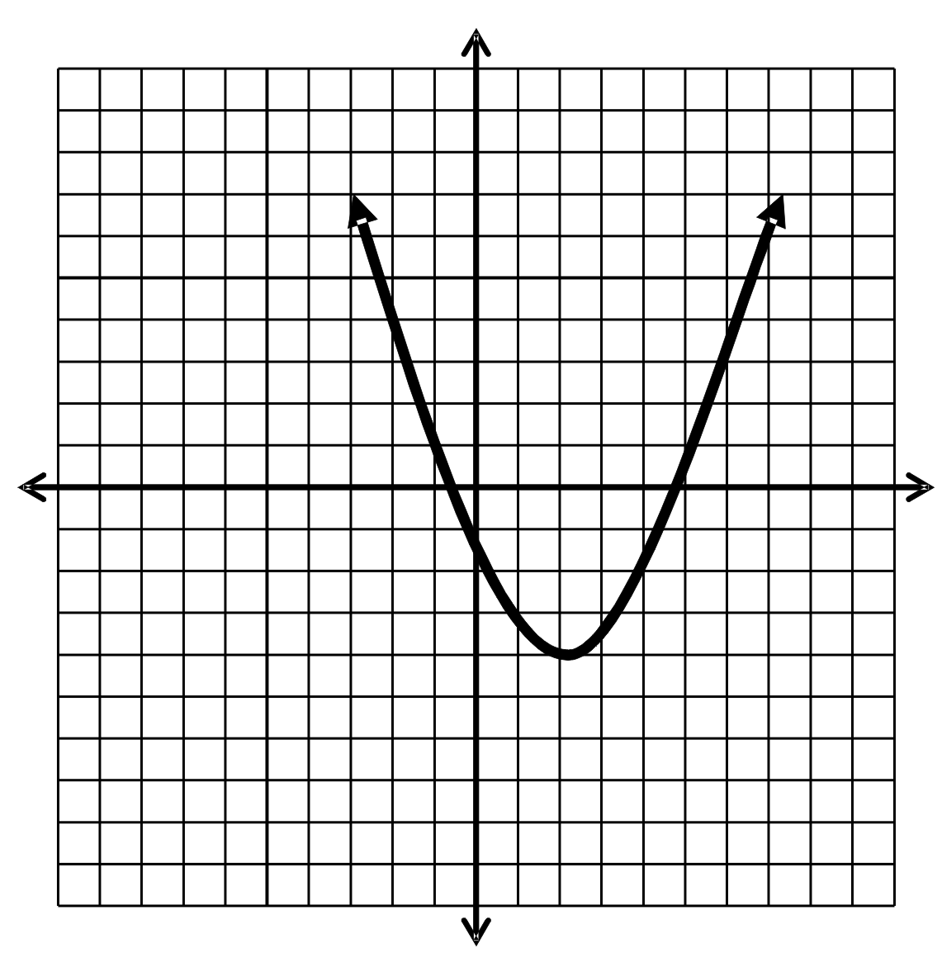

Using the grid below, student A sketches the graph described by student B.

5.3.2: Key Features of Quadratic Relations

Terminology | Definition | How Do I  Label It? | Graph A | Graph B
Vertex | The maximum or minimum point on the graph. It is the point where the graph changes direction. | (x,y)
Minimum/ maximum value
Axis of symmetry
y-intercept
x-intercepts
Zeros

Label the graphs using the correct terminology.

Graph A Graph B
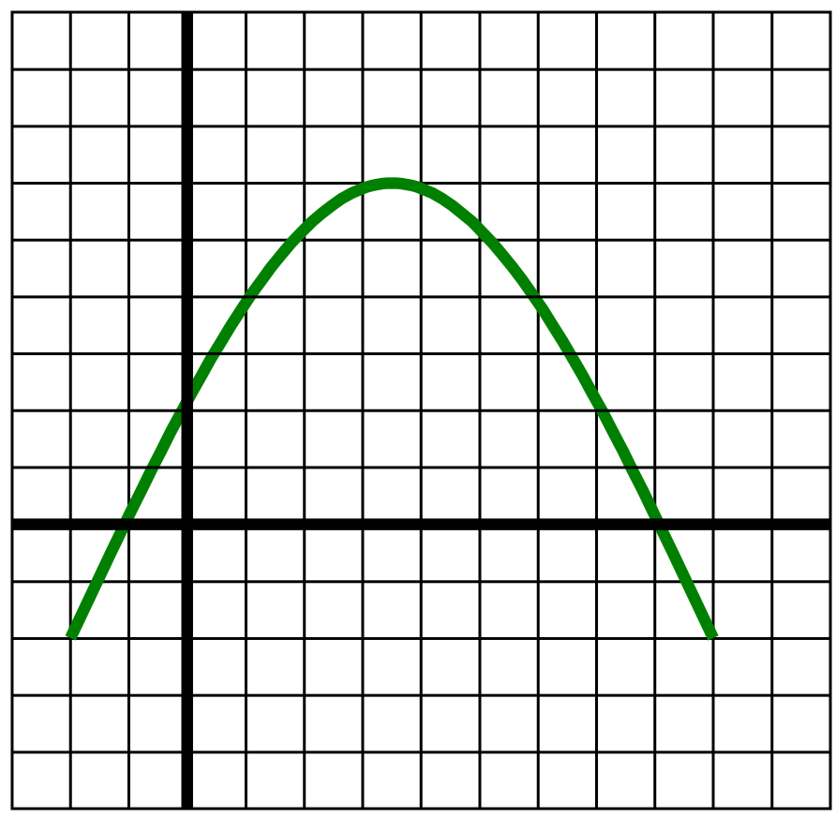
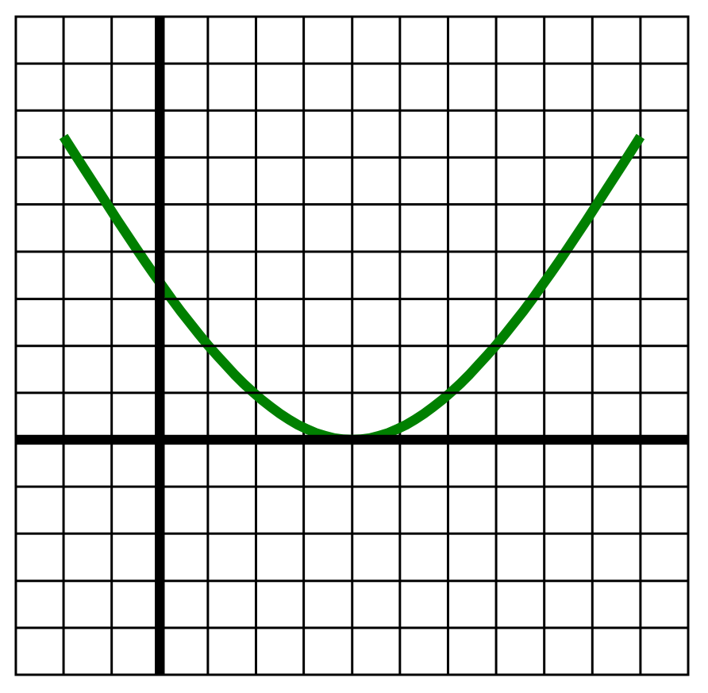

5.3.3: Key Terminology

vertex
Axis of symmetry

y-intercept
zero
zero
Maximum
value
Minimum
value

Unit 5: Day 4: Canada’s Baby Boom |  |  |  |  | Grade 10 Applied
  75 min |  | Math Learning Goals  - Collect data that can be represented as a quadratic relation from secondary sources.  - Graph the data and draw a curve of the best fit (parabola).  - Interpret data related to the context such as the maximum or minimum height.  - Determine that quadratic relations are of the form y = ax² + bx + c using technology. |  |  | Materials  - graphing calculators  - BLM 5.4.1, 5.4.2, 5.4.3
Assessment
Opportunities
 | Minds On… | Individual à Summarizing  Students complete a Frayer model for one feature from the previous day’s lesson (BLM 5.4.1). |  | Provide small graphs of parabolas to include on their model.  Fathom™ can be used as an alternative to handheld technology.  Note: The correlation coefficient will be needed to discuss the quality of the fit for each model. This authentic data contrasts the “clean data” collected and analysed Day 1 and 2 of the unit.
 | Action! | Individual à Exploration Using Technology  Students complete BLM 5.4.2 as an example of quadratic regression. They consider what kind of equation will model the data.  Students use quadratic regression to find equations for data collected on Day 1.  Make the connection between y = ax² + bx + c as the equation for a quadratic relation and the parabola.
 | Consolidate Debrief | Whole Class à Discussion  Students share their responses to the following questions with respect to the graph of “Canada’s Baby Boom.”  - What is the vertex of this parabola?  - In what year did the number of births reach a maximum?  - Why do you think this year had the greatest number of births?  - What was the maximum number of births?  - Could you use a parabola to represent birth rates for other periods of time? Explain.  - Is the parabola useful for predicting births into the future?  Curriculum Expectation/Application/Checklist: Assess students’ use of the graph to answer related questions.
Application  Reflection |  | Home Activity or Further Classroom Consolidation  Complete worksheet 5.4.3.

5.4.1: Key Features of a Parabola

Write the feature of a parabola that you were given in the centre of the graphic. Complete the chart. Include sketches and graphs with your work.

Definition | Facts/Characteristics
Examples | Non-examples  Parabola

5.4.2: Quadratic Power – Modelling Canada’s Baby Boom

Your Task
The Baby Boom occurred right after World War II. Determine if a parabola can be a useful model for the number of births per year for this post-war Baby Boom period.

Procedure

To access Canada’s Baby Boom data
1. Open the E-STAT website at http://estat.statcan.ca.
2. Select your language of choice. Click Accept and Enter at the bottom of the screen.
3. Click Search CANSIM on the left side bar and then click Search by Table Number.
5. In the blank box, type 053-0001 to retrieve Table 053-0001 – Vital statistics, births, deaths, and marriages, quarterly.
5. On the subset selection page choose as follows:
- Under Geography, select Canada
- Under Estimates, select Births
- Under From, select Jan. 1950
- Under To, select Dec. 1967
6. Click the Retrieve as Individual Time Series button.
7. In the Output specification screen under output format selection,
click the down arrow and select Plain Text Table, Time as Rows.
Year | Births
1950 | 372009
1951 | 381092
1952 | 403559
1953 | 417884
1954 | 436198
1955 | 442937
1956 | 450739
1957 | 469093
1958 | 470118
1959 | 479275
1960 | 478551
1961 | 475700
1962 | 469693
1963 | 465767
1964 | 452915
1965 | 418595
1966 | 387710
1967 | 370894
8. From “The frequency of the output data will be” pull-down menu, select Converted to Annual (Sum).
9. Press the Go button.
10. Record the data on a sheet of paper using the following headings: Year and Births.

Graphing Calculator Analysis
1. Create a Births vs. Year scatter plot on your graphing calculator.
2. Perform a Linear Regression on your graphing calculator.
Write the equation of the line.
3. How well does the Linear Regression fit the data?
5. Perform a Quadratic Regression on your graphing calculator.
Write the equation of the line.
5. How well does the Quadratic Regression fit the data?
6. Which regression best describes the data?

Source:
http://www.keypress.com/fathom/pages/community_exchange/activities_and_documents/activities.php
5.4.3: Modelling Canada's Baby Boom

You examined Baby Boom births in Canada, between 1950–1967.
Sketch what you think the graph of the number of births in Canada between 1950–2005 might look like.

Explain your reasoning and any assumptions you made.

Births in Canada 1950–2005

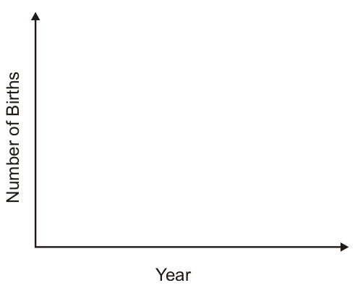

Unit 5: Day 5: Data Collection Using Balls |  |  |  |  | Grade 10 Applied
  75 min |  | Math Learning Goals  - Use technology to collect data that will produce a quadratic relation.  - Interpret data related to the context.  - Make predictions based on the context of the relation. |  |  | Materials  - BLM 5.5.1, 5.5.2  - graphing calculators  - CBR/CBL  - 3 different types of balls
Assessment
Opportunities
 | Minds On… | Groups of 4 à Form a Hypothesis  Demonstrate that three different types of balls bounce to different heights.  Students make two hypotheses about the bouncing balls, guided by the questions:  - What will be the shape of the graph that represents the height of the ball over time?  Students describe the shape of the graph in words and make a sketch, and include the reasons for their hypothesis.  - Will the time in the air between the first bounce and the second bounce vary depending on which ball is used?  If yes, students hypothesize the order, from the longest time in the air, to the shortest.  They include reasons for their hypotheses (BLM 5.5.2). |  | Other similar experiments can be used that model quadratic relations using technology, e.g., ramp activities.  The balls chosen should bounce to different heights, e.g., beach, soccer, basket.  Students in each group can change responsibility at each station, e.g., ball dropper, recorder, technology person, and task coordinator.  Collecting the data can be expedited by setting up two areas in the room, each area having three stations (one station for each type of ball). Divide the class into two large groups and form groups of four within each to rotate through the three stations.  Encourage students to draw from their reasoning skills and their understanding of science and physics throughout the discussion.
 | Action! | Groups of 4 à Experiment  Groups complete the ball bounce experiment (BLM 5.5.1), using technology to gather data that can be modelled with a quadratic relation, and analyse the graph. Prompt students in the analysis of their graphs by asking relevant questions.  Students revise their hypothesis and reflect on their original reasoning.  Math Process/Communication/Mental Note: Circulate among groups, listen to their language, check for correct use of terms for the parabola, e.g., vertex, maximum.  Groups transfer the data from BLM 5.5.2 to chart paper for each of the balls, colour coding the data for different balls. Groups post their results.
 | Consolidate Debrief | Whole Class à Sharing and Guided Discussion  Ask some groups to present their data, graphs, and analysis. They refer to maximum height, when it occurs, and time taken between first and second bounce. They share their original hypothesis and their reflections on their original reasoning, as well as new learning.  Lead a discussion about the different scales groups chose for recording their data and the relative merits of each. Determine the length of time in the air, on average, between the first and second bounce for each ball type, and the order from the most time in the air to the least. Refer to the horizontal intercepts, and what they mean in terms of the experiment.  Examine the shape of the graph (parabolic) and discuss the connection to the horizontal axis representing time. Identify key features of the graph and their meaning in terms of the context, e.g., maximum height, and when it occurs, axis of symmetry, to reinforce previous learning.  Ask questions that require students to analyse the graphs acknowledging any discrepancies in the results of different groups and discuss why they may have occurred. Discuss authentic situations where knowing the relationship between height and time may be important, e.g., space launch/firecrackers/movie stunts.
Practice |  | Home Activity or Further Classroom Consolidation  Search for data that confirms or refutes your graphs from the previous Home Activity regarding Baby Boom data.  Complete the practice questions that require interpretation of quadratic graphs generated by real data. |  | Provide students with appropriate practice questions.

5.5.1: Ball Bouncing Instructions

Record your hypothesis on the Ball Bouncing Record Sheet.
Use the CBR and the graphing calculator to examine the relationship between the bounce heights of your ball versus time after it is dropped from 1 m.

Instructions to Use Technology
1. Press the APPS button on your calculator and select CBR/CBL.
2. Follow the instructions on the calculator screen and press ENTER.
3. Run the Ranger program on your calculator.
5. From the main menu of the Ranger Program, select 3:APPLICATIONS.
5. Select 1:METERS and then select 3:BALL BOUNCE.
6. Follow the directions on the screen of your calculator. Release the ball so that the bottom of the ball is 1 m above the floor. The CBR should be at the same height as the bottom of the ball. Drop the ball and then press the trigger key on the CBR just before the ball strikes the ground. Try to keep the CBR steady as it collects the data. This may take a little practice.
7. Your graph should have a minimum of 3 bounces. If you are not satisfied with the results of your experiment, press ENTER, select 5:REPEAT SAMPLE, and try again. Repeat it until you get a nice graph of the ball bouncing.

Data Collection
The goal is to capture the motion of the ball that represents the period from the first bounce to the second bounce.
1. Press ENTER to return to the PLOT MENU. Select 7:QUIT to exit the Ranger Program. The data that you will work with will be in L1 and L2.
2. Use the built-in Select feature of the calculator to select the data you want. Follow the keystrokes below.
a) Press 2nd [STAT], scroll over to OPS menu and then scroll down to #8:SELECT, (and press ENTER.
b) After the bracket (, enter where you want to store the selected data. To use L3 and L4, press 2nd L3 [,] 2nd L4 and ENTER.
c) To actually select a part of the graph you will use, use the arrow keys to move to the left end of the parabola that you want to keep. This should be the first bounce. Press ENTER. This sets the left bound. Use the arrow keys to move to the right end of the parabola that you want. This should be the second bounce. Press ENTER. The selected data will be placed in L3, L4 and then this data will be displayed.
d) Sketch a graph of this single parabola using the instructions and grid provided on your Ball Bouncing Record Sheet.
3. Repeat the experiment for each of the different balls.

5.5.2: Ball Bouncing Record Sheet

Hypothesis

1. We hypothesise the shape of the graph that represents the height of the ball over time
will be _______________________________________________________________

Sketch the graph. Explain your reasoning.

2. We hypothesise the time in the air between the first and the second bounce will be for each ball.

Explain your reasoning.

Data Collection

Follow the steps described on the Ball Bouncing Instructions sheet.
To make a graph of each ball bounce, use the TRACE function or the LIST found using the STAT key EDIT from the graphing calculator, to complete the table of values for 7 points, starting at the first bounce and ending with the second bounce. Include the maximum point. Choose an appropriate scale to make an accurate sketch of the graph.

1. Ball type: ___________________
Times (s) | Height (cm)
 | 0
 | (max)
 | 0

5.5.2: Ball Bouncing Activity (continued)

2. Ball type: ___________________
Times (s) | Height (cm)
 | 0
 | (max)
 | 0

3. Ball type: ___________________
Times (s) | Height (cm)
 | 0
 | (max)
 | 0

